Cadence Health

Final Report

Mobile Application

Version 1.0, 13/11/14

Table of Contents

1. Introduction 3

2. Project Planning 4

3. Requirements and Analysis 5

4. Design 6

5. Implementation 7

6. Conclusion 8

7. RTM 9

# Introduction

RateMyPlate is the mobile application that has been developed on the Android operating system for the business Cadence Health. Cadence Health provides individuals, organisations and groups with nutrition training, resources, books and information.

This introduces the problem identified, as the majority of existing business products and services cater to individuals who already have an invested interest in nutrition, people who have bought and read relevant books and/or have taken part in nutrition training. Cadence Health needed a way to reach new demographics.

Thus a mobile application was proposed, catering to the “average person”, a person who may not have the time to undergo nutrition training or purchase and read any number of the books provided.

The focus of the application is on the Oxygen Radical Absorbance Capacity (ORAC) rating, which is a method of measuring antioxidant capacities in biological or food samples. Whereas higher values imply stronger antioxidant capabilities.

While the exact relationship between the ORAC value of a food and its health benefit has not been established, it is believed that foods higher on the ORAC scale will more effectively neutralize free radicals. According to the free-radical theory of aging, this will slow the oxidative processes and free radical damage that can contribute to age-related degeneration and disease.

Dieting is currently being used as a means to lose weight, although research shows that dieting yields negative results in the long run as it promotes low self-esteem towards body image. The purpose of the mobile application was to help create a shift away from dieting and calorie counting, to a move towards healthier eating.

This has been achieved through the use of functions and tools available within the application such as the ability to view a meals ingredients and its subsequent ORAC rating. The details of which are further discussed within this document.

# Project Planning

Deliverable 1: Feasibility Study (Monday 18/08/14):

In the first deliverable the group discussed the feasibility of the application mainly looking at the functionality it would provide. A number of issues arose when the requirements the client wanted in the application were beyond the expertise of the team. After a brief discussion a set of compromised functionalities were agreed upon.

Deliverable 2: Project Plan and Requirements Document (Monday 08/09/14)

A week before the second deliverable was due, a meeting with the client was held to discuss which functionality would be classified as core functionality and which functionality would be classified as secondary functionality. With secondary functionality to be started once core functionality was completed. This was due to the timeframe permitted to deliver the project.

Deliverable 3: Updated Project Plan, Updated Requirements Document, Design, Test Cases, Prototype (Tuesday 07/10/14)

A week before the third deliverable was due the team once again met up with the client to primarily present the first prototype and receive feedback. Upon discussion with the client after the presentation the team decided to implement two new functionalities, the first being the ability to access photos stored locally on the phone as well as choosing to take a photo at the time of application use. This was marked as core functionality. The second was the ability to upload old meal captures to the remote server. This was marked as secondary functionality.

Deliverable 4: Updated Project Plan, Updated Requirements Document, Updated Design, Updated Test Cases, Updated Prototype (Friday 31/10/14)

After presenting the second prototype of the application to the client the team sat down for a discussion to hear the client’s opinion on progress thus far. A final piece of functionality was proposed, the ability to review a captured meal and show exactly how each ingredient contributes to the final ORAC score. The client then walked the team through the exact color scheme she would like in the final version of the application as well as a change in images representing different functionalities of the application.

Deliverable 5: Project Presentation and Software Demonstration, RTM, User Manual and Final Report (Thursday 13/11/14)

Final Deliverable: Delivery of Product to Sponsor (Thursday 04/12/14)

At the time of writing this report the final application is yet to be delivered so it is relatively early to draw final conclusions, although it is the teams opinion that the amount of meetings with the client was adequate as it was difficult to discuss functional requirements with the client without providing visual aids, such as mock designs and prototypes. If the amount of meetings was cut in half the final application presented may have looked and operated in an unrecognizable fashion compared to the one currently being developed.

# Requirements and Analysis

The requirements and analysis of the clients needs was complex at first but was easier to grasp once the feasibility study was completed. It allowed us to quantify the client’s needs and ensure we had worked out all the tangible benefits that we had to ensure were realised.

This allowed us as a team to focus on what the essentials were and what the Clients expectations are and what is to be done. It became apparent that the potential health impacts and positive changes to people’s eating habits was a major motivator for the Client and the organisation.

The decision was made by the Client to have a mobile application developed, so that it would be widely available to all people regardless of their prior understanding of nutrition. It was also immediately apparent that an APP for and Android phone would work for most people because of its ease of use and universalness.

Several alternative solutions were looked at from no solution to a fully-fledged Android App with everything initially proposed by the Client. Each were looked at and were studied, but ultimately a simpler version of the proposed application was decided upon for a range of reasons: time frame, expertise was limited, background knowledge and information about ORAC (for Team) were the main limiting factors and made the decision for what was included and a what wasn’t a lot easier.

The team should have however chosen a slightly more scaled down solution, as the complexity of the tasks was not immediately apparent and quickly grew immensely. There should have also been more direct contact with the client to ensure this was communicated more effectively, along with a more realistic idea of what was feasible. But this leaves room for further increments and versions, and allows the application to grow as parts are finished and implemented successfully.

# Design

The Design of the APP was crucial because of our Clients need for it to be user friendly and simple to use. It also had to present the information in and easy to understand and simple manner. This made certain alternative designs impractical and others more suitable.

The mobile APPLICATION is designed to be a standalone APPLICATION running on an Android smart phone, which will allow users to better track and manage their meals so they can become healthier and improve their wellbeing.

The main feature of the APP is to allow users to take and image and tag the main ingredients and have an ORAC rating generated from these Tags. Another main feature of the APP is to allow the USERS to look at previously saved and tagged meals, and allow them to see the details for each meal.

They will also be able to search meals uploaded by other USERS to the web database, so that they can get a better idea of healthy meals and what other people are doing. This would make the APP more social and interactive for the USERS.

However, even with these implemented perfectly the APP cannot exist without context and this is important when on a mobile device. This is because the context can change and vary between USERS and must be taken into account.

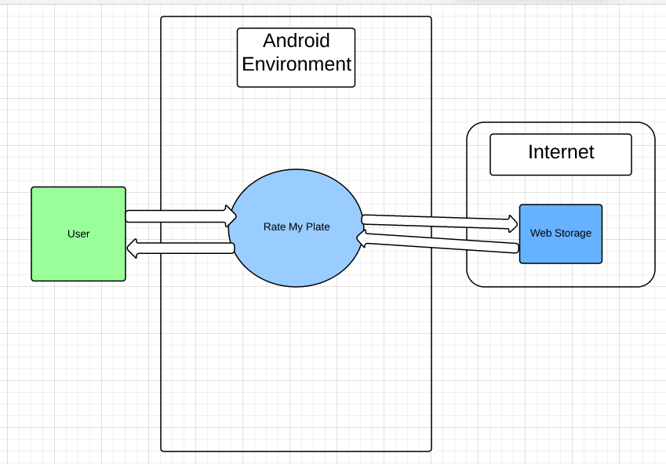

The APP runs on a smartphone within the ANDROID environment. The USER interacts with the phone and the APP, but not directly with the web database. The APP communicates and takes care of operations between the web database and phone. This was chosen as it limits the possibility for human error and makes the Query process much fast and efficient.

Tagging as a method of data input was chosen as it is familiar to a wide range of smartphone users and is simple in design. Tagging was also chosen as it allows specific ingredients to be chosen, and makes searching for meals much more specific.

Also the current research on ORAC ratings are done by an ingredient to ingredient basis, so it made sense to utilise this research in the same way.

Another main function of the APP is to take images of the users meals. This is to both make the app more interactive, and to make it more appealing. The Client also wanted the application to be similar and familiar to social media such as Facebook, Instagram and LinkedIn. This familiarity also again makes the app easy to use and appealing t o a wide number of users.

If we were to undertake the Application again the design would be very similar, but would incorporate social media into it and make the application more social so that the community involvement can be greater.

# Implementation

For the implementation of the Application the team decided that an AGILE approach was best suited. This was because it: met the requirements of the unit, allowed prototypes to be rapidly tested and feedback given on each, a preview of the final application before completion, rapid feedback from the Client. This was crucial as meeting and checking the Application met the Client’s needs was key in the implementation.

To start with the implementation was slow as requirements were gathered but once an understanding of what was required was built up, the development moved along more quickly.

Every week there were two meetings to discuss what was to be done in the week coming and one later in the week to go over any issues we had completing various tasks. There was also regular attendance by the Client every 2 weeks to see how progress was going. This was very beneficial during the implementation, as things could be changed and seen in the next implementation. This led to better client feedback and minimal design changes as the app progressed.

For the future implementation of the Application, there needs to be further iterations in the design process and other parts such as the web database must be implemented. This is a realistic goal if the timeframe was longer and permitted more iterations of the SDLC. With further iterations the team could further enhance the APPs features and could ensure it met all the Clients requirements.

# Conclusion

The application developed meets all the core requirements that the team set out to achieve. As a result of this it is the teams opinion that the application solves the problem area addressed in the introduction. The team has provided Cadence Health with a tool to better spread nutrition information to a new demographic.

There is still future work to be done on the application though, as there are still requirements discussed with the client that the team simply did not have the time to implement. The first of which is the ability to share photos with other users both through the use of social media as well as through the application itself. This would require Cadence Health to upgrade their current server package to include the capabilities of SQLite. There are also a number of smaller functionalities that the client would like to see implemented in the foreseeable future, such as the ability to add the geo-location of a captured meal.

In conclusion it is the regret of the team that we didn’t have more time to implement all the features initially discussed, although we are very happy with the final product we are presenting as it adequately solves the problem identification.

# RTM

|  |  |  |  |  |  |  |
| --- | --- | --- | --- | --- | --- | --- |
| Requirement ID | From Requirement ID | To Requirement ID | Type | Use Case/s | Build No | Remarks |
| R1.1 | R1.1 | R1.13 | Essential | Create Meal | V1.0 | Complete |
| R1.1.1 | R1.1 | R1.1.1 | Essential | Create Meal |  | Complete |
| R1.2 | R1.1 | R1.4 | Essential | Create Meal | V1.0 | Complete |
| R1.3 | R1.3 | R1.4 | Essential | Create Meal | V1.0 | Complete |
| R1.4 | R1.4 | R1.3, R1.2 | Essential | Create Meal | V1.0 | Ongoing |
| R1.5 | R1.2 |  | Essential | Create Meal | V1.0 | Complete |
| R1.6 | R1.2 | R1.5 | Essential | Create Meal | V1.0 | Complete |
| R1.7 | R1.7 |  | Essential | View Meal | V1.0 | Complete |
| R1.8 | R1.3 | R1.4 | Essential | View Meal | V1.0 | Complete |
| R1.9 | R1.5 | R1.6 | Essential | View Meal | V1.0 | Complete |
| R1.10 | R1.4 | R1.3 | Essential | View Meal | V1.0 | Ongoing |
| R1.11 | R1.2 |  | Essential | View Meal | V1.0 | Complete |
| R1.12 | R1.2 |  | Essential | Search Meal | V1.0 | Ongoing |
| R1.13 | R1.2 |  | Extensional | Search Meal | V1.0 | Ongoing |
| R1.14 |  |  | Essential | Search Meal | V1.0 | Complete |
| R1.15 |  |  | Essential | Search Meal | V1.0 | Complete |
| R1.16 |  |  | Essential |  | V1.0 | Ongoing |
| R1.17 |  |  | Essential |  | V1.0 | Complete |
| R1.18 |  |  | Essential |  | V1.0 | Complete |
| R1.19 |  |  | Extensional |  | V2.0 | Complete |
| R1.20 |  |  | Extensional |  | V2.0 | Complete |
| R1.21 |  |  | Extensional |  | V1.0 | Complete |
| R1.22 |  |  | Extensional |  | V2.0 | Complete |
| R1.23 |  |  | Extensional |  | V2.0 | Complete |
| R1.24 |  |  | Extensional |  | V2.0 | Complete |
| R1.25 |  |  | Essential |  | V2.0 | Complete |
| R1.26 |  |  | Essential |  | V2.0 | Complete |
| R1.27 |  |  | Extensional |  | V2.0 | Complete |
| R1.28 |  |  | Essential |  | V2.0 | Complete |
| R1.29 |  |  | Extensional |  | V2.0 | Complete |
| R1.30 |  |  | Essential |  | V2.0 | Complete |
| R1.31 |  |  | Essential |  | V1.0 | Complete |
| R1.32 |  | R1.46, R1.47, R1.48 | Essential |  | V1.0 | Complete |
| R1.33 |  |  | Essential |  | V1.0 | Complete |
| R1.34 |  |  | Essential |  | V1.0 | Complete |
| R1.35 |  |  | Essential |  | V1.0 | Complete |
| R1.36 |  |  | Essential |  | V1.0 | Complete |
| R1.37 |  |  | Extensional |  | V1.0 | Complete |
| R1.38 |  |  | Essential |  | V1.0 | Complete |
| R1.39 |  |  | Extensional |  | V1.0 | Complete |
| R1.40 |  | R1.6 | Essential | Create Meal | V1.0 | Complete |
| R1.41 | R1.40 |  | Essential | Create Meal | V1.0 | Complete |
| R1.42 |  |  | Essential |  | V1.0 | Complete |
| R1.43 |  |  | Essential |  | V1.0 | Complete |
| R1.44 |  |  | Essential |  | V1.0 | Ongoing |
| R1.45 |  |  | Extensional |  | V1.0 | Ongoing |
| R1.46 |  |  | Essential |  | V1.0 | Complete |
| R1.47 |  |  | Essential |  | V1.0 | Ongoing |
| R1.48 |  |  | Essential |  | V1.0 | Complete |